**Add Second Edge Node with R and RStudio in HDInsight Cluster**

When the edge node running R and RStudio servers in a HDInsight cluster is getting too busy, you may want to create a second edge node and another set of R and RStudio servers. The following steps show you how to do this by using Azure ARM template and Azure HDInsight Script Action.

1. Log into Azure Portal and create a R server cluster with one work node and Storage Account without Domain Join.
2. Use this template to add the second edge node with R server:

<https://docs.microsoft.com/en-us/azure/hdinsight/hdinsight-apps-use-edge-node>

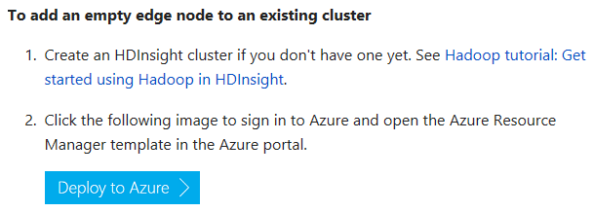

Note: The current script picks a D3 V2 edge node and named new-edgenode. You can change this by using “Edit Script”.

Here is the template:

{

"$schema": "https://schema.management.azure.com/schemas/2015-01-01/deploymentTemplate.json#",

"contentVersion": "1.0.0.0",

"parameters": {

"clusterName": {

"type": "string",

"metadata": {

"description": "The name of the HDInsight cluster to be created. The cluster name must be globally unique."

}

},

"_artifactsLocation": {

"type": "string",

"metadata": {

"description": "The base URI where artifacts required by this template are located. When the template is deployed using the accompanying scripts, a private location in the subscription will be used and this value will be automatically generated."

},

"defaultValue": "https://raw.githubusercontent.com/Azure/azure-quickstart-templates/master/101-hdinsight-linux-add-edge-node/"

},

"_artifactsLocationSasToken": {

"type": "securestring",

"metadata": {

"description": "The sasToken required to access _artifactsLocation. When the template is deployed using the accompanying scripts, a sasToken will be automatically generated."

},

"defaultValue": ""

},

"installScriptActionFolder": {

"type": "string",

"metadata": {

"description": "A script action you can run on the empty node to install or configure additiona software."

},

"defaultValue": "scripts"

},

"installScriptAction": {

"type": "string",

"metadata": {

"description": "A script action you can run on the empty node to install or configure additiona software."

},

"defaultValue": "EmptyNodeSetup.sh"

}

},

"variables": {

"applicationName": "new-edgenode"

},

"resources": [

{

"name": "[concat(parameters('clusterName'),'/', variables('applicationName'))]",

"type": "Microsoft.HDInsight/clusters/applications",

"apiVersion": "2015-03-01-preview",

"dependsOn": [],

"properties": {

"marketPlaceIdentifier": "EmptyNode",

"computeProfile": {

"roles": [

{

"name": "edgenode",

"targetInstanceCount": 1,

"hardwareProfile": {

"vmSize": "Standard_D3_v2"

}

}

]

},

"installScriptActions": [

{

"name": "[concat('emptynode','-' ,uniquestring(variables('applicationName')))]",

"uri": "[concat(parameters('_artifactsLocation'), '/', parameters('installScriptActionFolder'), '/', parameters('installScriptAction'), parameters('_artifactsLocationSasToken'))]",

"roles": [

"edgenode"

]

}

],

"uninstallScriptActions": [],

"httpsEndpoints": [],

"applicationType": "CustomApplication"

}

}

],

"outputs": {

"application": {

"type": "object",

"value": "[reference(resourceId('Microsoft.HDInsight/clusters/applications/',parameters('clusterName'), variables('applicationName')))]"

}

}

}

1. In Portal, use HDInsight script action utility to install RStudio on the new-edgenode:

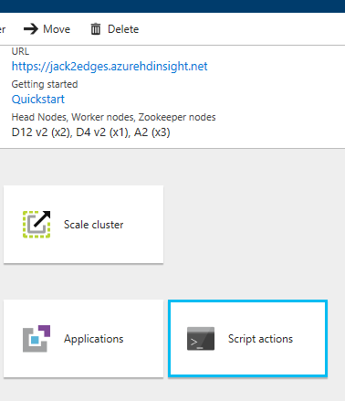

Note: using this URI

<https://hdiprodrstudio.blob.core.windows.net/rstudio-open-version/rserver-9-1/rstudio-0-99-902-02/InstallRStudio.sh>

To keep the RStudio on the first edge node and on the new-edgenode in the same version.

1. Checking the cluster:

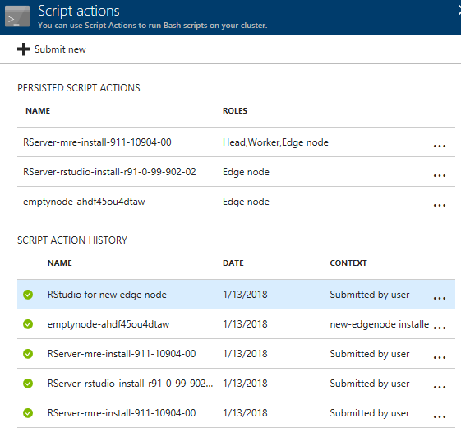

1. Checking RStudio

Start a Putty session with a tunnel:

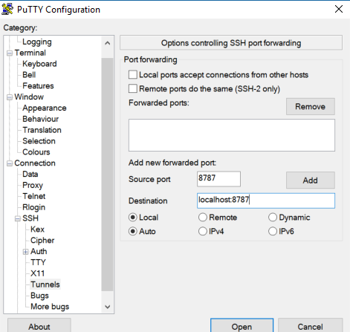

Click ADD then OPEN. You will be prompted for SSH user ID and password.

Now you can start the web browsing session with the URL of <http://localhost:8787/>. You should see the RStudio auth-sign-in page.